University of Hertfordshire
(Hertfordshire International College)


EDUCATIONAL LEANING APPLICATION FOR YOUNG PEOPLE
(EAZYCYBER)
CSP102 MINI PROJECT
HIC ID- 29972
EZEKIEL OLUSEGUN, ADESEGUN

SUPERVISOR- HAMZA HAMZA

Abstract
This project proposes an Android application for young adults, to help them in their self-study and bring Cyber Security to them, while still in high schools or college. The average digital young adults find mobile learning a new and preferred method against the traditional learning method from various research. Pattern commonly preferred for learning by the young adults is known as MCQ (Multiple Choice Questions) to other approach. This project has integrated this pattern into the application using the right tools such as, Android Studio with java code to implements functions that creates a friendly interface for the user.

Table of Contents
Abstract 2
1. Introduction. 5
1.1 Aim of Project 5
1.2 Objective of project 5
1.3 Background research: 6
Requirement Analysis: 6
Design: 6
Implementation: 6
Testing: 6
2. Research background 7
2.1 Gantt chart 7
2.2 Literature review 8
2.2.1 Education history 8
2.2.2 Computer programming 9
2.2.3 Mobile application 9
2.2.4 Mobile Learning 10
2.2.5Android phone and Application Market 11
2.2.6 Cyber security 12
2.3 Market Gap 12
2.4 Introduction to Java programming 13
2.5 Android Studio 13
3. Requirement Analysis 15
3.1 Functional requirement 15
3.1.1Use case details 16
3.2 Nonfunctional requirement 16
4. Design 17
5. Implementation of project 22
5.1 Structure of application 22
5.1.1 Java directory includes: 22
5.1.2 Res directory 23
5.2.1 Drawable Package 24
5.2.2 Layout package 24
5.2.3 Value package 24
6. Testing 25
Conclusion 26
Reference: 27

1. Introduction.
Educational application for teaching and learning were not as accessible as it very much available presently. The evolution of education could be traced to the early days of humans that used symbols and signs for learning, then the introduction of schools, which had classrooms for proper learning process and all the curriculum in order by the sole person responsible for administration. The person was often a product of education in a higher hierarchy, who is deemed qualified to become an administrator(C N Trueman 2015).
Before now, there are applications(apps) out there that teach various aspect of education. Whatever field of study in the world today, there are already developed applications that can be used for teaching and learning. Educational learning applications are mostly used for cognitive purposes by schools or organizations to help enhance the learning process(Jacobs et al. 2019).
Educational applications on Cyber security on the other hand, have started gaining grounds in the league of applications. A lot of applications on Cyber security are mainly targeted at becoming an expert in Cyber security, with an already knowledge in either computer science, any science field and already professional in other fields, which is a standard for understanding the teachings involved.
EazyCyber is a tutorial application for young people to learn Cyber security. This application uses the interactive learning approach fit for learning among young people. The application uses e-book technology to create a cognitive pattern for easy understanding and an-end section of questions and answer, for knowledge testing of young people after each section in the application.

1.1 Aim of Project
The aim of this project is to create an educational learning mobile application that will enhance the cognitive learning of young adult on Cyber Security. They get to read the content of application through the different sections and answer questions after each reading.

1.2 Objective of project
To achieve the aim of this project, the following areas have been outlined

1.3 Background research:
Research has been carried out on how to develop educated mobile applications for young adults. I have carefully looked at the pattern to which young adults can easily understand in mobile application development. Young adults in schools are majorly made to undertake exams in schools to progress to the next class or level. Multiple choice questions (MCQ) are commonly used in the classrooms to ascertain the level of understanding for each topic taught during the term. For this project, multiple choice questions (MCQ) is the pattern am implementing for the cognitive learning in young adult.

Requirement Analysis:
- Determine use case and actors.
- Determine the functional and non-functional requirements of the application.

Design:
- Designing the interface of the application.
- Creating the interaction between each activity of the application.

Implementation:
- Create the login page of the application.
- Create a function for the reading different sections.
- Create a function for the Multiple-Choice Question (MCQ).

Testing:
Testing the user interface to meet the user requirements

2. Research background

2.1 Gantt chart
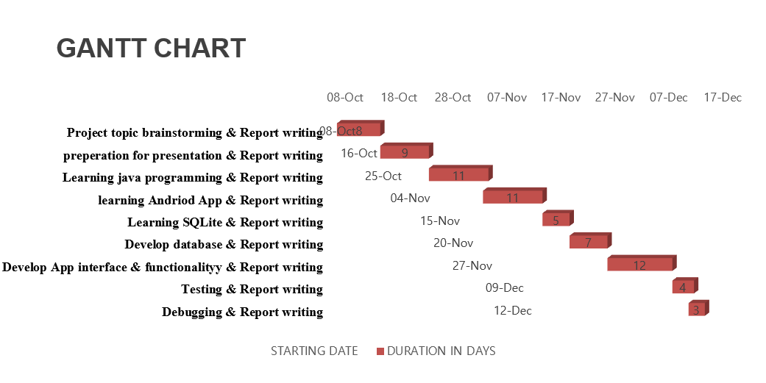
Figure 1: Gantt chart of project
Developing the application for this project was achieved through different phases. According to Duffy (2016), Gantt chart are the roadmap to draw before undertaking in any project. He also states that Gantt chart are common type of productivity tool that helps to visualize the project from start to finish. The following are the stages of the Gantt chart:
- Project topic brainstorming and report writing: the stage was to come up with an idea of what project to undertake for the Pre-masters, considering the time for the semester is about 12weeks in total.
- Preparation for presentation and report writing after a topic or idea is gotten, I had to prepare for the presentation to obtain an approval for the take-off of the project.
- Learning java programming: I had to do a bit more research on java programming language for the coding part of the project.
- Learning Android Studio App: the project development requires a platform, which is the software for developing applications of such kind. Understudy of the Android Studio features was done.
- Learning SQLite and Database creation: the application would require a database to store the data like the answers of each user. Due to the time of the project, there was not enough time to work on the database feature of the app. I intend to continue after the semester to implement the database.
- Develop App interface and functionality: Android Studio is used to build the interface and the functionality of the application from the scratch to finish.
- Testing: testing of the interface to meet the goal of the application by putting data in the application.
- Debugging and report writing: the application is tested and corrected for bugs.

2.2 Literature review
Today in the world, we are presented with the fact that learning is an important aspect of man’s existence. Passey et al. (2018) in his article, explained that the “western world” are better developed in areas that best matters, because of their involvement in learning. He further puts his thought on the advantage of countries that have experts or professionals in different fields. It can be attributed that the development of USA, UK and other G7 is solely owned to these countries engaging their citizens to learning.

2.2.1 Education history
Education can be traced back to the Romans in the early days of human race (C N Trueman 2015). Truman, states that only the rich in Ancient Rome put a great faith in education. They were mainly tutored by a private tutor at home or went to what they called a school, which was an extension of a shop but separated from the crowd by a mere curtain(C N Trueman 2015). The British education was formed and subsequently ,British education ACT1870 was introduced (Https://www.parliament.uk/, 2019). The ACT1870 was the first piece of legislation to providing education in Britain.
Although the relationship between the colonial education and economic growth are considered topics of interest (Biyase and Kirsten 2020). A huge significant of colonial education can be seen in countries like South Africa, where the impact of education has truly become commendable (Biyase and Kirsten, 2020).

2.2.2 Computer programming
One of the many advantage of educational is the birth and rise of computer programming in schools. Randell (1994) examines the origin of programming to the achievement of those that did well on a scale of values according to the knowledge and belief in science in the early days. He also has the opinion that history of computer programming started with the ideas of Charles Babbage, and for century long, it was hard to be surpassed. In addition, Bergin (2007) in his work on celebrating the history of programming, he tagged his conference which he started in 1978 as (HOPL), meaning the History of Programming Language. He attributed the inventors of all programming languages that existed. The aim of the conference was to outline the influence of each computer programming language in terms of its rationale. Also, Mullen (2016) publication, gave insight to the history of programming in America. He idea was to keep the history of programming and teach it to people for understanding of the great work of programming.
The first successor for Babbage was Percy Ludgate, who was an Irish accountant in 1903, at the age of 20, performed decimal arithmetic by mechanical means (Randell 1994). Ludgate also was the one that presented the use of subroutines in the programming environment.

2.2.3 Mobile application
Mobile applications are considered as one of the most popular and needed applications, as they have a friendly interface for supporting most areas of human life(Saifan and Al-Rabadi 2017). The percentage of consumers that use mobile application for both personal and business use as seen a great leap over the years. Schools and business have adopted mobile application as part of their process to sharing information (Pappas, Giannakos and Sampson 2019). Also, mobile application adoption by young adults greatly increased significantly over the years, as smart phones are emerging through smart technology from all the makers of smart phones (Ramsey et al. 2018). In addition, Taylor, Voelker and Pentina (2011) in their work, confirms the rate of mobile adoption as at the time of publication to be 44% of mobile users, who are age 13 and above.
Using mobile phones for learning has helped increased the rapid pace in educational technology(Journal et al. 2018). Learning by mobile phones, such as smart phones, tablets, multimedia and other portable devices are better known as M-learning(Journal et al. 2018). According to Journal et al., (2018), states that mobile learning creates attitude and it generates an intention of positive behavior which helps in the area of learning.
Also, Silva et al. (2019) in their work, presented a journal on the adoption of Android application for teaching elementary school children.

2.2.4 Mobile Learning
The average children and youngsters today, are considered digital natives because they were born in the digital age, therefore, they are quick to adapt to the technology available to us(Silva et al. 2019). The present young adult have opportunities that were not available to the older generation when growing up in a traditional settings of non-digital facilities in schools and homes(Silva et al. 2019).
Attewell (2003), in her work, Literacy today had done some research on mobile learning among youths. She had expressed concerns on the negative results on text messages affecting the spelling of student. Her research had concluded that mobile learning was going replace traditional education, as mobile phones offer young people unparalleled opportunities to attain knowledge and good communication skill(Attewell 2003).
Dey (2013) also aggress with mobile learning as a powerful too in the hands of the young adult. The author says the young adults have developed a strong bond with studying on their phone rather than a hard copy book. She also talked about mobile learning as the tool to changing youth. The young adults have become media-savvy, gadget-savvy, and tech-savvy and are completely relaxed and feel competent in this environment(Dey 2013).
Also, Andone, Dron and Pemberton (2007) evaluates the digital student in their work. Generations born after 1980 the digital world is more present and pervasive than the people born before that time(Andone, Dron and Pemberton, 2007). They used a scenario-based design method to develop a scenario for an eLearning space and called it DIMPLE (Digital Internet and Mobile Phone e-Learning Environment). They engaged two focus group in Romania and UK to collect in-depth, qualitative information, opinions and characters about the digital students’ characteristics and the proposed DIMPLE scenario. The participants were of different nationalities and both gender was considered for the focus group(Andone, Dron and Pemberton 2007). From their research perspective, ‘digital students’ were young adults or students who had grown up with active participation in technology and this is a daily routine for them(Andone, Dron and Pemberton, 2007).
In addition, Higgins (2013) conducted a five-year research in New Zeeland, on the process of leaning for young student who left school with few or no qualification. The research shows the ability of the young students, to developing self-study through mobile learning platform through help of their community, from a program called Education Employment Linkage (EEL) project (Higgins 2013).

2.2.5Android phone and Application Market
Acceptance of Android by users are on the increase daily, with the emerging features available to the users. Android phones have over 85% of the global market share in 2018(FRPT 2018). according to Suh and Park (2018), the industry is undergoing a tremendous transformation for the mobile community by advances in mobile computing. He also says the innovation of technology in hardware and software aspect to telecommunication have greatly boosted the capabilities of mobile products and services. According to him, there are more than three million applications in Google’s “Play Store” and Apple’s “App Store”. The explosive growth of the mobile application is as a result of millions of applications that cut across various fields such as education, communication, health care, and entertainment(Suh and Park 2018). The value of the application market is expected to hit over 200 billion dollars(Suh and Park, 2018).
Also, (Golhar et al. 2016) concours to the rapid growth of technology through mobile application globally. In their paper, they explored the powerful resources in Android Studio and presented a detailed android base application for an institute. Golhar et al. (2016) states that Android provides a fully functional framework that allows user to produce innovative applications based on the need of the society.
Mobile applications through smartphones was firstly introduced and developed by Apple(Suh and Park 2018). Consumers select smartphones based on the consideration of the applications available to them in the application markets such as Android and Apple store(Suh and Park 2018). Google’s Android Market “Play Store” and Apple’s Market “App Store” are the two major applications market available and mostly used by consumers to source for applications to download for free or pay for it. Both markets have categories of applications that consumers can access such as, social networking, entertainment, business and finance, games, travel, religious material and utilities.

2.2.6 Cyber security
When the internet became a part human in carrying out some important task, the need to protect oneself from risks of been attacked by various forms was important for everyone who is the user (Dunkel 2017). The emergence of Internet of Things (IoT) has created more cyber threats in context of overall business risk (Dunkel 2017). Information security has been classified to have become a huge aspect of power, diplomacy, and armed conflict for long span of time and information’s role in national relations has increased due to the proliferation of information and communication technology(Dunn Cavelty 2012). Dunn Cavelty (2012) further describes Cyber Security as insecurity created by and through the new place/space and the practice or process to make secure.

2.3 Market Gap
There are educative learning applications that already exist, the likes of GoConqr and Quizlet and many more. Most of this application are developed for general purpose and targeted at their core subjects only. GoConqr allows the user to download the application onto their phone and they can study their subjects, like math, science, geography, history, drama. However, these applications are only focused on their study and intended for the young adults to open them up to Cyber Security. As at some few years back, the Defense Department on Cyber Security Intelligence of United State of America created an application called “cyberroot” in a plan to encourage coding among young adults. They developed the application to teach coding but soon the app stopped functioning as they did not continue to support of this application. Eazycyber is going to be a great application to teach cyber security to young adult in high schools. Eazycyber will create cyber security adoption into the minds of the young adults and further help in determining their prospects to studying cyber security in the university. Been a tutorial application, there will be benefits from the functions available on the application, as each section will be well structured to educate them on the Cyber security awareness, Cyber bullying, Cyber terrorism, Cyber Phishing. The Multiple-Choice Question (MCQ) feature of the application will create a cognitive learning, thereby making the application interactive for the users.

2.4 Introduction to Java programming
Java is programming language widely used for applications development for decades now. It is an object-oriented programming language (OOP), such that the object method can be accessed and modified in the fields which they are linked. Java programming is directly derived from C++ programming language. (Cavaiani 2006) in his journal, states that java programming language is gaining much acceptance for programmers as it provides the principles such as code reuse, inheritance, and overloading. He further stated the objectives of the Java Class Library assists student in learning searching techniques for locating specific classes and methods in the Java Class.
JVM – Java Virtual Machine: for every lines of code in application, the JVM converts them into compactible codes. These codes can then be run on several CPUs and operating systems(Tanner 2000). According to (Golhar et al. 2016), it is impossible for applications to be executed in Android applications.

2.5 Android Studio
Android Studio was announced in 2013 at the Google I/O conference, based on Eclipse, an environment for application development(Silva et al. 2019). Android Studio is recognized as the most complete IDE for developing any application with rich features to meet the goal of the programmer and stands out from other programs which can be used for developing applications(Silva et al., 2019). In Android Studio, a rich and extensive set of views are available to use in the development of an application, containing list, grids, text boxes, buttons and embeddable web browser(Golhar et al. 2016). Also, the resource manager, which provides access to non-code resources which includes strings, graphics and layout files. A notification manager that display alerts I the status bar.
Android Studio also has XML feature, which is an Extensible Markup Language, that defines set of collection rules for encoding records in formats that are easily human-readable and machine-readable. XML is a textual data format with robust support through Unicode for different human language(Golhar et al. 2016).
Android Studio has inbuilt database function called SQLite. Golhar et al. (2016), defines the SQLite in Android Studio as in-process library that carry out a self-contented, server-less, zero-configuration, transactional SQL (Structured Query Language).

3. Requirement Analysis
The educational learning application am creating is to be downloaded into an Android phone. Allowing users to have a self-taught concept for learning Cyber Security. The project includes features for creating a profile, where each user puts his/her name in the login page. A welcome page is displayed, and the user is given instruction on how to navigate their way through the sections and the questions available after each section is read through. In general, Eazycyber is a tutorial application for understanding and learning Cyber security and targeted at the young adults. It creates a self-learning advantage for self, as user can read through the contents and attempt the multiple-choice questions (MCQ) from anywhere, or place.
-login access: Users are required to login to gain access into the application
-Section reading: Users are select the sections options available to read and at the end of each section reading, they can attempt the multiple-choice questions and aim to get a high score, depending on their level of assimilation.
-score: Users can see their score after each Multiple-choice question they successfully attempt.
For the requirement process, research was done on what pattern best is preferred to young adults

3.1 Functional requirement
The functional requirements for the educational learning application are best explained in the below figure.
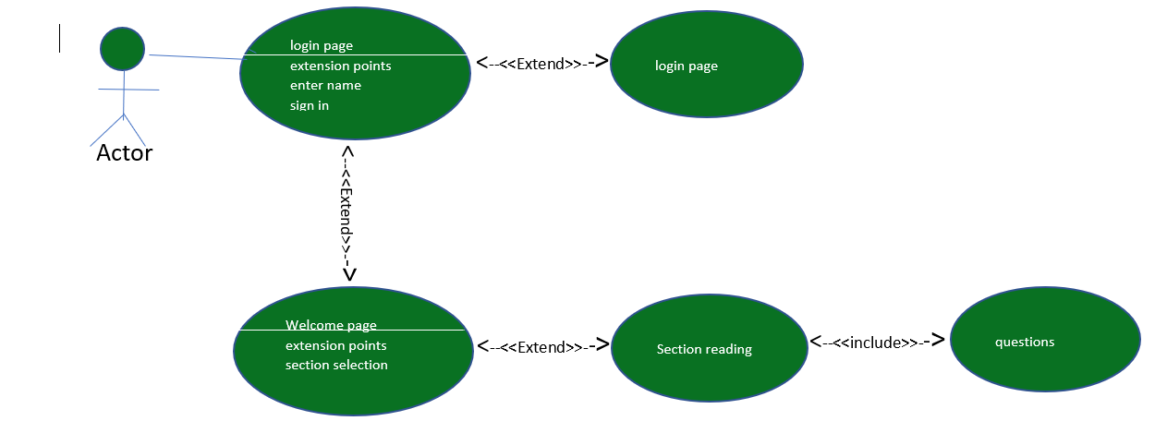
Figure 2: Use case diagram

3.1.1Use case details
1-Login page
Description: this describes the scenario that the user gets to put in their names to begin the tutorial.
Actors: Users (young adult)
Input: the user enters their preferred name and then clicks the sign-in button to continue.
Output: The name the user enters in the textbox is collected and the next activity is opened.
2-Welcome page
Description: This scenario describes the actions to read the different sections of the application.
Actors: user (young adult)
Input: user gets to select from the available sections to read.
Output: the user can see and read the content in the section selected and answer the Multiple-choice question at the end of the section.

3.2 Nonfunctional requirement
Since nonfunctional requirements looks at how the system should work. Eazycyber has the following nonfunctional:
-The layout of the application is simple and easy to interact with.
-the application processes the selected parts of the application quick, without delays.
-Navigating the interface is easy to understand.
-User friendly simplified English words for better assimilating, as this application is for young adult. The application is void of professional jargons that are ambiguous.

4. Design
In order to achieve the aim of the project, the designing of the application is done with simple interface and good layout to attract the young adults.

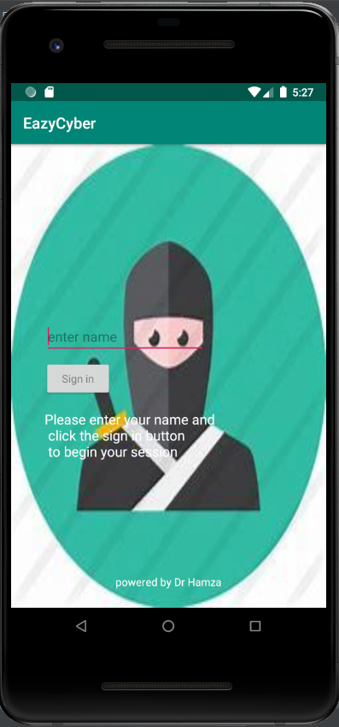
Figure 3: User interface Login page

From the above image, when the user downloads the application from the store, upon installation, they are can access the login page immediately. This is the first activity that the users must interact with. The login page will require the user to enter a preferred name into the textView box and click the sign-in button to begin using the application

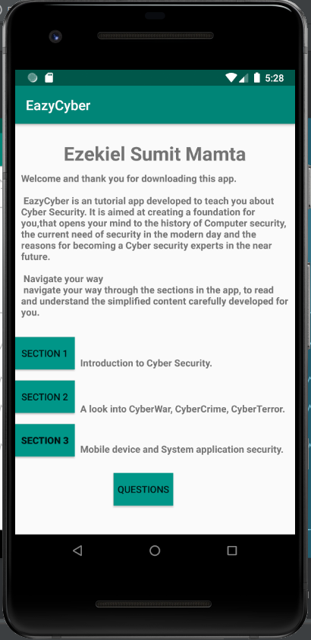
Figure 4: User interface welcome/ Section selection

Figure 4 above is displaying the name of the user from the login page. The name is displayed at the top with some information to the user about the application. The next is the instruction to the user on what they can do on this page. The user gets to pick from the section and read through the content. Each section is like a chapter in a book.

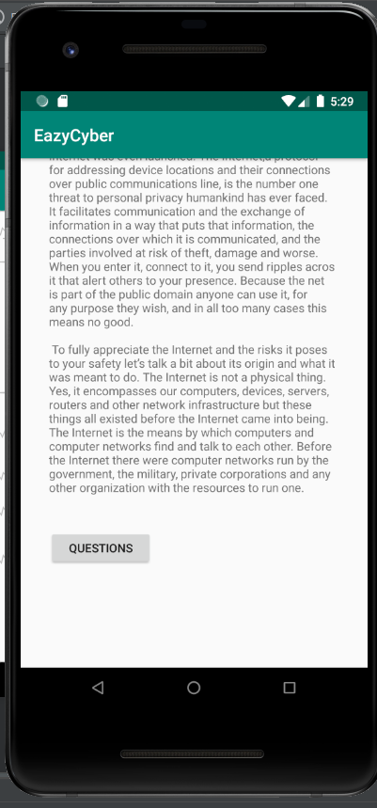
Figure 5: User interface section 1 reading

In the above figure5, the user can read the content in the section one, which is the introduction to Cyber Security. They have a scrollable feature to read through a long length of characters. At the end of their reading, they click on the questions button to begin the questions activity.

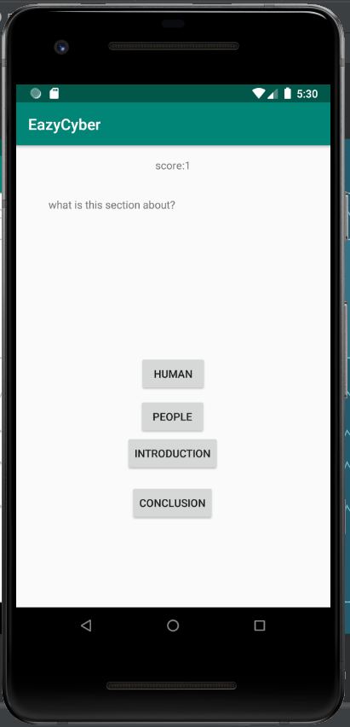
Figure 6: User interface for Questions for section

Figure 6, interface is where the questions about what the user has read in the section one. The top view is the score of the user which is initially set to zero. The score increases by 1 for every correct question answered rightly. There four buttons with choices for the user to select from.

5. Implementation of project
The development of the educational learning application was done with the concept of MVC architecture (Model, View and Control).
MVC can be traced as far back as 1979, when Trygve Reenskaug, a researcher who was working on the Smalltalk language at Xerox Corp.’s Palo Alto Research Center, first got his hands on the architectural pattern for building application(Peterson 2005). MVC helps to separate an application’s data model, user interface and control login into three different components, or objects(Peterson 2005). The author outlined the primary benefits of MVC pattern as increase in the responsiveness of the view component while maintain the stability of the data model.
The model is a class that contains object’s information (data), while the View is the interface of the application that interacts with the user, and the Control receives requests from the user, the request is processes and passed to the View for the user to see(Peterson 2005). The View part of the MVC architecture is visible to the user, and the rest is hidden from them.

5.1 Structure of application
Android programming has a clear distinction between resource and source code. Since the source code for this application is written in java code, the resources are the files unrelated to java code such as, image files, audio, video, text files, colors, etc. the following are the two mainly used sections in the application:
Java directory and res directory:
-Java directory manages Controller and Model handle
-Res directory contains View related files.
Java directory

5.1.1 Java directory includes:
- MainActivity
- MainQuestion
- Questions
- Section_one
- Section_two
- Section_three
- WelcomeActivity
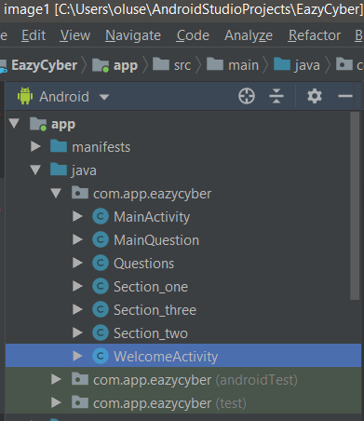
Figure 7: Java activity

Android Activity is the place for the applications to interact directly with users through the interface. An application may contain multiple screen and each screen may be an activity.
Each Activity usually operates independently from each other but can interact and data can be transferred to each other through Intent Keyword.

5.1.2 Res directory
Res directory includes:
- Drawable package
- Layout package
- Mipmap package
- Values package

5.2.1 Drawable Package
The package is defined as graphic to allow the programmer load image. It allows the inclusion of images to the application as background images.

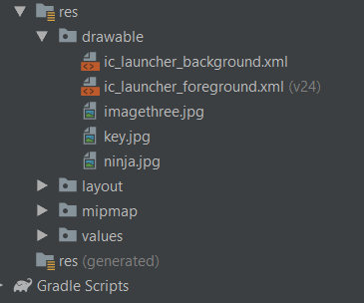
Figure 8: Drawable package

5.2.2 Layout package
Layout is the component that defines the user interface structure or in other words, a component that decides the interface of a screen in the application. Layout supports the alignment of widgets (TextView, Button, and EditText) as I used in the application for the display of messages or taking inputs from user. In Layout package, constraints are very important in the designing of the application. Each layout file has the extension name of “xml”.
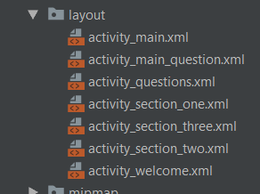
Figure 9: Layout package

5.2.3 Value package
The Value package contains colors, dimens, strings and style. The color.xml allows the developer to attributes colors for the background and more options are available too. Dimens.xml is an abbreviation for dimensions, helps the developer to defines all the sizes of the views or other components in the application, including the font size into the same resource file to easy management. String.xml is a basic form of resource in the Android Studio. It helps to provide built-in text for the views, which can be a label of TextView, Button’s label, hint for EditText. The Style.xml helps the programmer to create a uniform interface for all activities.

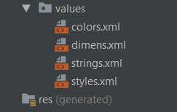
Figure 10: values containing attributes

6. Testing
No | Task | Result | Problem | Correction
1 | User login | pass
2 | Displaying user information | pass
3 | Selection of section to view | Pass
4 | Scroll view for section reading | Pass
5 | Select question button | Pass
6 | Attempt questions | Pass
7 | Display score for user | pas

Conclusion
In conclusion, the development of this educational learning application has reached a workable stage from the inception of the project idea. The objectives outlined for this project have been completed with thorough research in Android application development process. The goal of creating a unique application to close the gap in the market has been very achieved with creating functions that allows young adults to want to take interest in Cyber Security and furthermore, increase their ability to engage in mobile learning. The users will gain cognitive knowledge on Cyber Security areas such as, the history, the Cyber Crime, Cyber Terrorism, Cyber Phishing, etc. The whole process has very valuable in terms of my exposure to building a functional application that works. It has opened me up for possible future interest in developing applications. I am not able to complete the database part of this project, because of time constraints and the process of understanding how to build an application from tutorials on YouTube and the likes. So, I have taken it upon myself to carry on with the database implementation during the holiday.

Reference:
Andone, D., Dron, J. and Pemberton, L. (2007) ‘evaluation of the digital students and dimple.’, Proceedings of the IADIS International Conference on Cognition & Exploratory Learning in Digital Age. International Association for Development of the Information Society (IADIS), pp. 139–146.

Attewell, J. (2003) ‘Mobile learning.’, Literacy Today. Education Publishing Worldwide Ltd, (36), p. 14.

Bergin, T. J. (Tim) (2007) ‘a history of the history of programming languages.’, Communications of the ACM. Association for Computing Machinery, 50(5), pp. 69–74.

Biyase, M. and Kirsten, F. (2020) ‘education and economic growth in cape and natal colonies: learning from history.’, Journal of Developing Areas. Tennessee State University, College of Business, 54(1), pp. 105–120.

C N Trueman (2015) Roman Education - History Learning Site, historylearningsite. Available at: https://www.historylearningsite.co.uk/ancient-rome/roman-education/ (Accessed: 7 November 2019).

Cavaiani, T. P. (2006) ‘Object-Oriented Programming Principles and the Java Class Library.’, Journal of Information Systems Education. Journal of Information Systems Education, 17(4), pp. 365–368.

Dey, S. (2013) ‘changing youth: intuitive technology.’, Feliciter. Canadian Federation of Library Associations (CFLA), 59(5), pp. 24–25.

DUFFY, J. (2016) ‘Using Gantt Charts to Get Things Done.’, PC Magazine. Ziff Davis, Inc., pp. 133–138.

Dunkel, D. (2017) ‘The Cyber 101 Discussion.’, Security: Solutions for Enterprise Security Leaders. BNP Media, 54(8), pp. 34–38.

Dunn Cavelty, M. (2012) ‘Cyber-Security’, in, pp. 362–378.

FRPT (2018) ‘Android phones to have 85% global market share in 2018: IDC.’, FRPT- Telecom Snapshot. FRPT Research, pp. 3–4.

Golhar, R. V et al. (2016) ‘Design and implementation of android base mobile app for an institute’, in 2016 International Conference on Electrical, Electronics, and Optimization Techniques (ICEEOT), pp. 3660–3663.

Higgins, J. (2013) ‘Towards a learning identity: young people becoming learners after leaving school’, Research in Post-Compulsory Education. Routledge, 18(1–2), pp. 175–193.

Https://www.parliament.uk/ (2019) The 1870 Education Act - UK Parliament, living-heritage. Available at: https://www.parliament.uk/about/living-heritage/transformingsociety/livinglearning/school/overview/1870educationact/ (Accessed: 7 November 2019).

Jacobs, A. et al. (2019) ‘Celebration, commemoration and collaboration: milestones in the history of education.’, History of Education, 48(2), pp. 151–155.

Journal, I. et al. (2018) ‘Uses of Mobile for Teaching and Learning, Effects and Influence Among Secondary Level Schools in Pakistan Muhammad Shahzad Ashfaq 1 , Nargis Abbas Mirza 2’, IV(I), pp. 57–64.

Mullen, L. (2016) ‘The Programming Historian.’, Journal of American History. Oxford University Press / USA, 103(1), pp. 299–301.

Pappas, I. O., Giannakos, M. N. and Sampson, D. G. (2019) ‘Fuzzy set analysis as a means to understand users of 21st-century learning systems: The case of mobile learning and reflections on learning analytics research.’, Computers in Human Behavior. Department of Computer Science, Norwegian University of Science and Technology (NTNU), Sem Sælands vei 7-9, 7491, Trondheim, Norway: Pergamon Press - An Imprint of Elsevier Science, 92, pp. 646–659.

Passey, D. et al. (2018) ‘computational practices, educational theories, and learning development.’, informatikos praktikos, ugdymo teorijos ir mokymosi pažanga. Vilnius University, pp. 24–38.

Peterson, T. (2005) ‘AJAX: MVC Redux.’, Computerworld. IDG Communications, Inc., 39(28), p. 34.

Ramsey, R. R. et al. (2018) ‘A pilot investigation of a mobile phone application and progressive reminder system to improve adherence to daily prevention treatment in adolescents and young adults with migraine.’, Cephalalgia. Division of Behavioral Medicine and Clinical Psychology, Cincinnati Children’s Hospital Medical Center, Cincinnati, OH, USA: Sage Publications, Ltd., 38(14), pp. 2035–2044.

Randell, B. (1994) ‘The origins of computer programming.’, IEEE Annals of the History of Computing, 16(4), p. 6.

Saifan, A. A. and Al-Rabadi, A. (2017) ‘Evaluating maintainability of android applications’, in 2017 8th International Conference on Information Technology (ICIT), pp. 518–523.

Silva, Í. R. S. et al. (2019) ‘Android app for Teaching and Learning Math for Elementary School Children’, International Journal of Advanced Engineering Research and Science, 6(3 SE-Articles).

Suh, Y. and Park, Y. (2018) ‘Identifying and structuring service functions of mobile applications in Google’s Android Market.’, Information Systems & e-Business Management. Springer Nature, 16(2), pp. 383–406.

Tanner, J. C. (2000) ‘Java goes to work.’, Telecom Asia. Questex Media Group, 11(11), p. 88.

Taylor, D. G., Voelker, T. A. and Pentina, I. (2011) ‘mobile application adoption by young adults: a social network perspective.’, International Journal of Mobile Marketing. Mobile Marketing Association, 6(2), pp. 60–70.

